ActiveLock Wizard User Guide

Contents
- Introduction
- Change History
- How To Use
- Online Resources

Introduction
Thank you for downloading this release of ActiveLock Wizard. ActiveLock Wizard is a tool to create a module file with all the controls in to integrate ActiveLock into your application in Microsoft Visual Basic 6.0 and in Microsoft Visual Basic 2005

Change History
V1.0.0 - Nov 25, 2007
- Initial release

How To Use
In Alugen Select the Destination Application to generate the code for
Then select the Wizard button to pass the info to the ActiveLock wizard
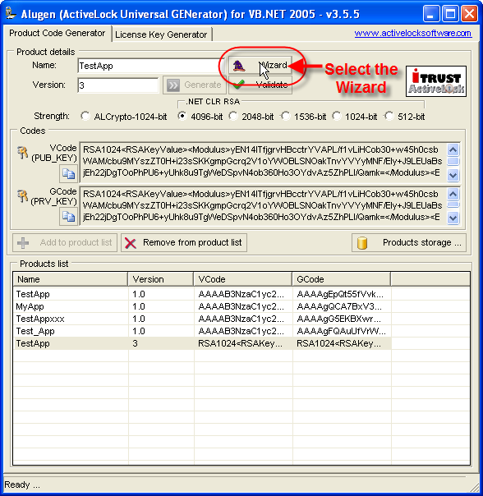
You will see the info passed from Alugen
Next you must select all the options you want in your new application
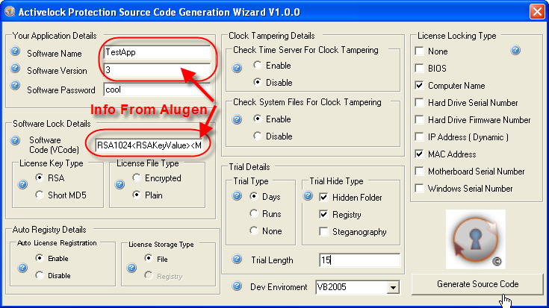
Select your development environment
Click on “Generate Source Code” to create the module that contains all the ActiveLock features for your application
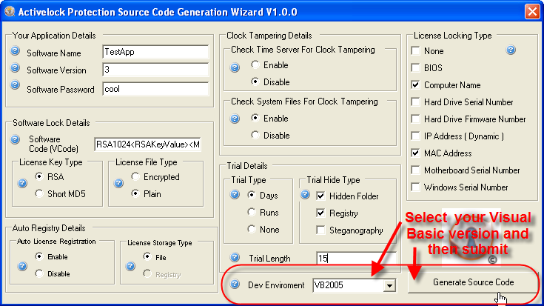
Select the destination for the newly generated file to be saved.
For VB6 the file name will be “modALVB6.bas”
And For VB2005 the file name will be “modALVB2005.vb”

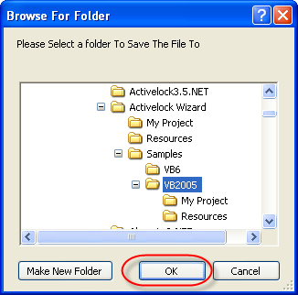
There are some very basic samples for VB6 and VB2005 to show you how to use the new modules in your application.
It is so easy to integrate ActiveLock into your application that you can add it to your existing application in a few minutes
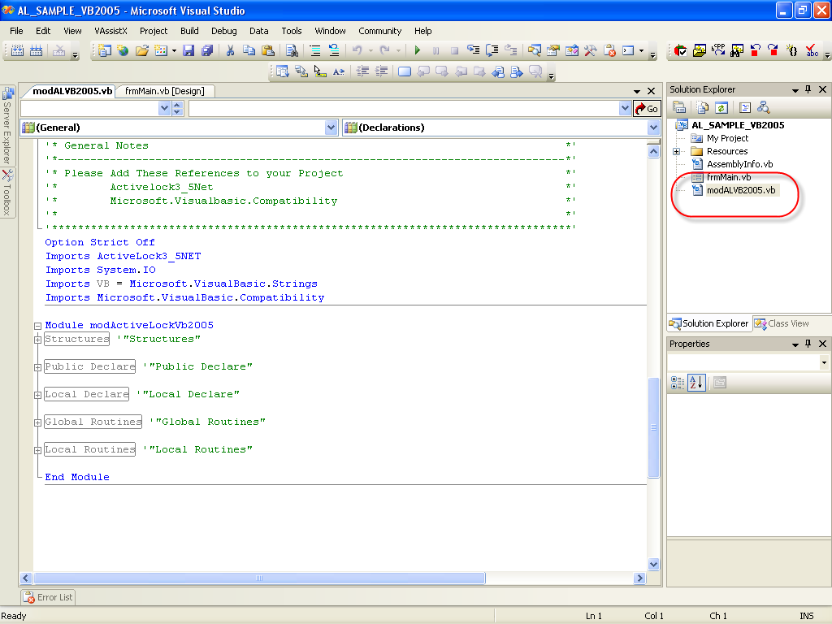

It is also possible to call ActiveLock wizard from your own keygen via a “DOS command”
This is the parameters to pass info to the wizard
"Activelock Wizard.exe" "AppName=Test App" "AppVersion=1.0.0" "PUB_KEY=frf4378t475gy54vgyw5g5y6cg556g576fg6f"
Please note that you do not need to start the wizard with the parameters included.
It is merely there to make it easier because of the length of the long VCode.

Online Resources
For additional information, refer to these ActiveLock pages on the World Wide Web:
ActiveLock Home Page
This is the official web site of The ActiveLock Software Group. Please check this site for documentation and other online resources.
ActiveLock Bulletin Board
You can also post questions and discussions here. This way any newcomers who have not joined our mailing list can also benefit from your discussions.

ActiveLockTM is a trademark of Nelson Ferraz
Copyright 1998-2002 Nelson Ferraz
Copyright 2003-2005 The ActiveLock Software Group (ASG)
All material is the property of the contributing authors.

